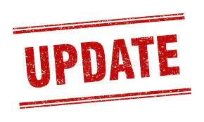
AUGUST 14, 2022
UPDATE: SOCIAL MEDIA POST INVESTIGATION
The joint investigation is actively on-going and the juvenile associated with the social media post has been identified. This person has been suspended from school pending the outcome of the investigation.
In an abundance of caution, and to allow investigators time to follow up on any and all leads, a joint decision was made to close the Gilpin County School for STUDENTS ONLY on Monday, August 15, 2022. We want to reiterate that the Gilpin County Sheriff’s Office, and the Gilpin County School District have a zero tolerance policy for any type of violence concerning our school community. An act, or threat of violence will be prosecuted to the fullest extent of the law.
The Sheriff’s Office and School Administrators want to assure our community that we have protocols in place and every effort is being made to ensure the safety of our school and everyone involved. We all have the same goal of a safe and productive school year and the Sheriff’s Office will be increasing our presence at the school.

